Important Individuals during Colonization

Read the information about each important person below. While reading, highlight at least 3 important facts per person that you could use to create a “living statue” for each historical figure.

Important Person | Facts
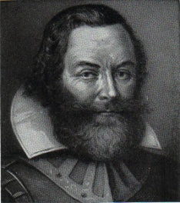  Captain John Smith | - English explorer who helped found the colony at Jamestown, Virginia in 1607  - He was a soldier, mapmaker, and trader  - He was also an author who described in detail his adventures in the colony of Virginia  - He is famous due to his association with Pocahontas, the daughter of Chief Powhatan, who according to legend saved the life of John Smith after he was captured by a Powhatan hunting party  - He was a leader at Jamestown and began a policy of “He who does not work, will not eat”
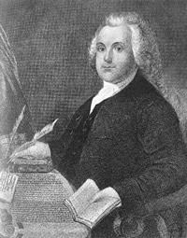  Roger Williams | - Leader of the Rhode Island colony  - Was a Puritan who left England to migrate to the New World  - Minister in Salem, Massachusetts who founded the first Baptist church in America  - In 1636 his strong views clashed with those of John Winthrop, the governor of Massachusetts, who banished him from the strictly Puritan colony  - Roger Williams fled the Massachusetts Colony and established a colony with religious freedom, which later became the state of Rhode Island
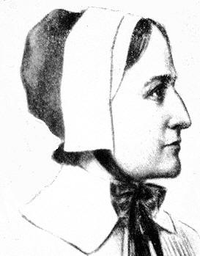  Anne Hutchinson | - One of the early colonists of the Massachusetts and Rhode Island Colonies  - Started a Women’s club and religious meetings in her home  - Believed that a person could worship God without the help of a church, minister, or Bible  - She was forced to leave Massachusetts because her religious views differed from the strict beliefs of the Puritans  - Anne Hutchinson and her followers left Boston in 1638 for the settlement that had been established by Roger Williams in Rhode Island
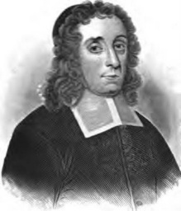  Thomas Hooker | - Leader of the Connecticut colony  - Puritan  - Became dissatisfied with the rigid practices and government of the Puritan church in Massachusetts  - Led a group of followers to start a new colony in Connecticut  - Inspired the "Fundamental Orders of Connecticut" which was one of the first written democratic constitutions that established a representative government
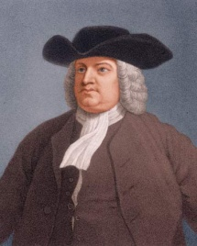  William Penn | - Joined the Quakers as a young man  - Created the colony of Pennsylvania where Quakers could live according to their religious beliefs  - The Quakers believed that all people should live in peace and harmony  - Welcomed different religions and ethnic groups to Pennsylvania  - Negotiated peaceful land purchases with the Native Americans
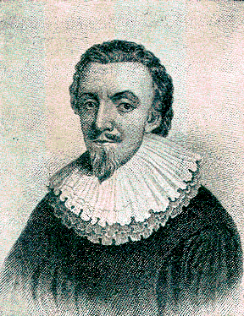  Lord Baltimore | - Founder of the Maryland colony  - Born with the name George Calvert and became known as “Lord Baltimore” when he received the title of Baron of Baltimore in 1625  - Wanted to create the Maryland colony as a refuge in America for English Catholics  - The charter for Maryland was officially granted five weeks after Lord Baltimore’s death on June 20, 1632  - Maryland became a refuge for Catholic settlers and thousands of British Catholics came to Maryland
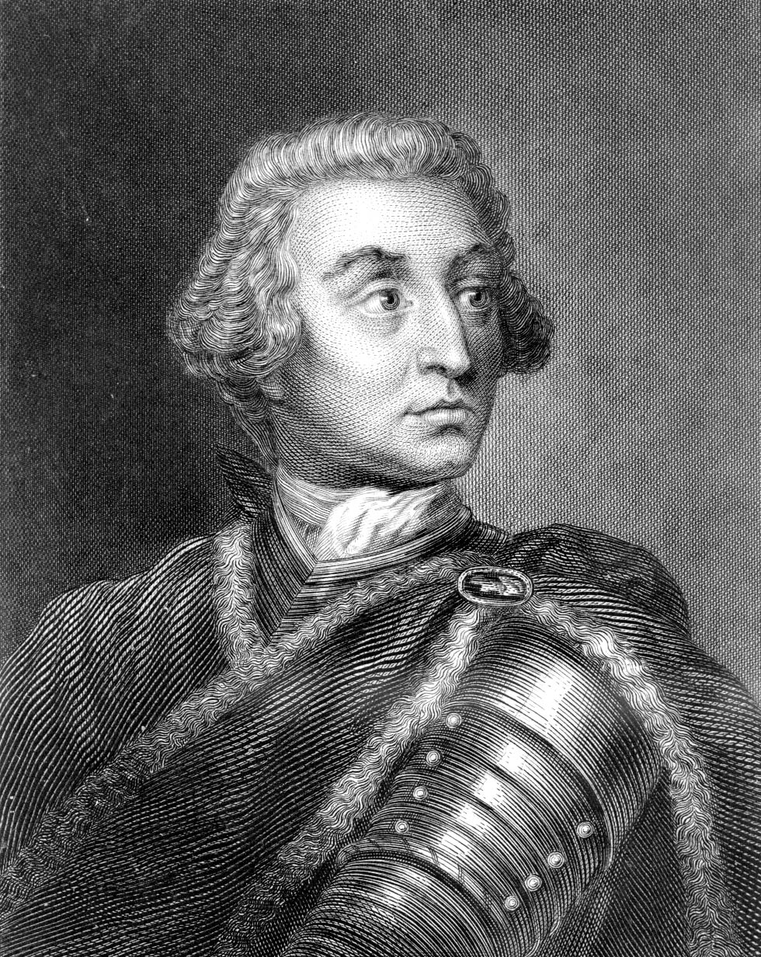  James Oglethorpe | - Elected to the British Parliament in 1722  - Became interested in helping others when his friend was jailed in a Debtor’s prison  - Founded Georgia in 1732 as a place for imprisoned debtors and convicts sent from England  - Led the defense of the territory during the war between England and Spain  - Set strict rules for the Georgia colony, which upset many of the colonists
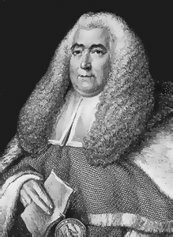  William Blackstone | - English judge and writer  - Wrote Commentaries on the Laws of England  - He explained in his writings his belief that a country’s laws must be based on God’s laws  - Defined the rights of individuals in English law, as well as property rights that could not be violated, even by the king  - His writings influenced many colonial leaders
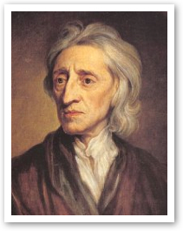  John Locke | - English philosopher  - Argued that people have natural rights (the rights to life, liberty, and property)  - Claimed that people create governments to protect their natural rights  - Wrote that government was a “social contract”  - He believed that if a government does not protect people’s natural rights, they have the right to overthrow the government  - Challenged the belief that kings had a God-given right to rule
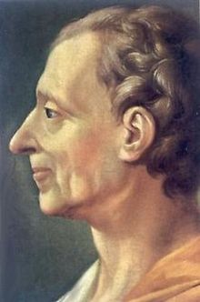  Charles de Montesquieu | - French political philosopher  - Author of The Spirit of the Laws (1748)  - Believed that a government elected by the people was the best form of government  - He thought the government should be divided into three branches with different but equal powers (separation of powers)  - Believed that liberty was only safe in small societies governed either by direct democracy of by legislatures with small districts

